**Heart Rate Monitor**

**With Bluetooth Functionality and Group Based Application**

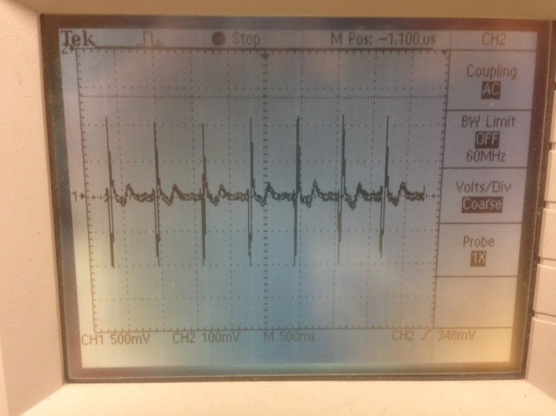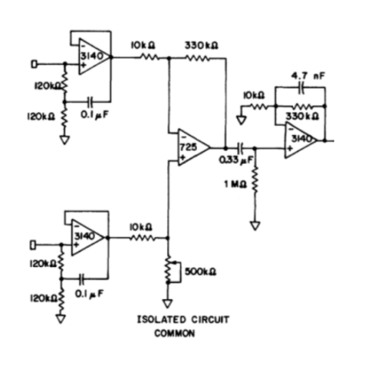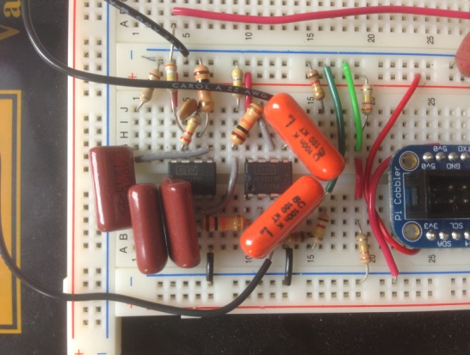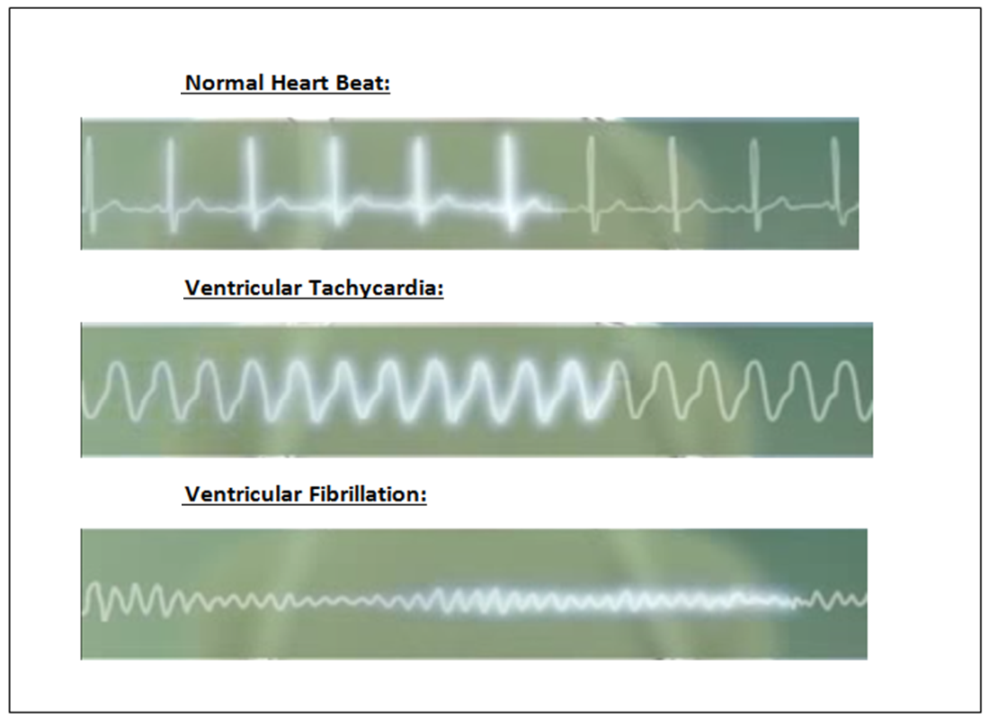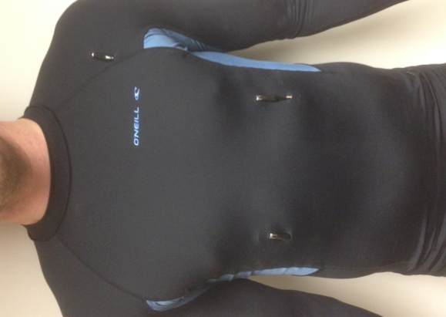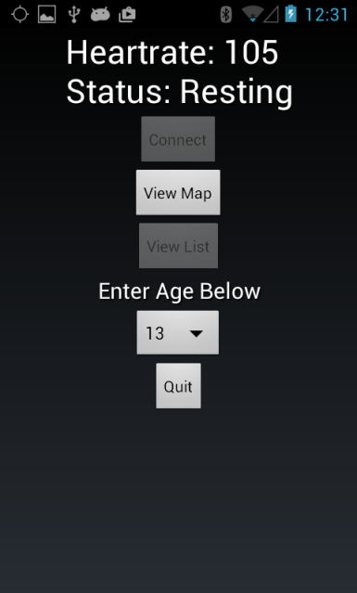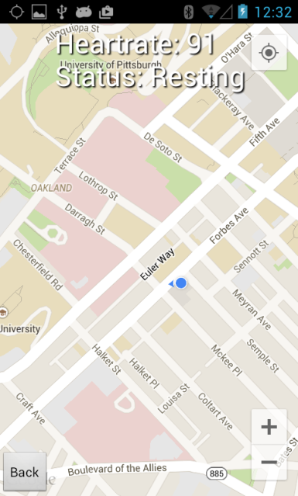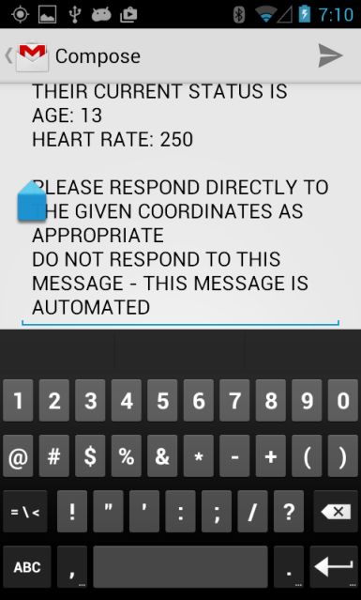

**V. Bluetooth**

There are several different communication methods we could have chosen for communication between a smartphone and the microcomputer.

* Wired (Restrictive to the user)
* WIFI (Tie up phone's ability to access internet)
* Bluetooth
* NFC

While certain properties of NFC would be beneficial over Bluetooth, in the end Bluetooth was chosen for its more universal adoption by smartphone manufacturers and end user familiarity with use.

* L2CAP protocol (UDP like protocol) would increase complexity for user
* We use RFCOMM Protocol. (TCP like protocol)

**VI. App**

The app is simple to use and intuitive, with 3 basic screens.

* Home screen (General Display)
* Map Screen (Displays graphical location of all users connected to the server)
* List Screen (List of all users connected to the server and their heart rates)

In the event that tachycardia or bradycardia is suspected, an email will be sent to a predetermined address alerting them of the user's heart issues. See above for an image of the home screen, map screen and the email client that is opened in the event of an emergency being detected.

**VII. Server**

The app connects to a main server over the internet using the TCP protocol to allow for the group functionality in the map and list view screens. The server stores an array of phone objects and sends this array to the phones to allow the users to view the heart rate, status, and locations of other users.

This server was constructed to demonstrate that a user sitting on the other side of the world can view up to date heart rate and GPS data of all participating members.

**VIII. Testing**

After integration we tested against a Polar H7 Heart Rate Sensor. Regularly they differed by <5% and at maximum of ~7% when exercising. As can be seen, the monitor we have constructed is accurate and a fully functioning product.

**IX. Evaluation**

This product is a proof of concept for a military based design. Basically, the smartphone would be removed and the app code run on the microcomputer. A satellite internet dongle would deliver internet around 95% of the world. As such, a commanding officer could sit behind his desk on the other side of the world and view up to date GPS and heart rate data on all his troops.

In addition, should the design go into mass production, an industrial construction of the vest with hidden electrodes and wires running through layers of the fabric would be made. Also, a joint ADC and amplifier circuit could be fabricated.

**X. Conclusion & Sustainability**

As a standalone product it has been very sustainable socially, environmentally and economically. It is a non-intrusive design and does not hinder anyone’s daily routines and even adds to keeping the user safe with its ability to notify emergency services should a heart condition be found. It has made use of the current smart phone market and also uses a microcomputer which is reusable. In the end the whole design would cost ~$80 including purchasing of the Raspberry Pi.

We have shown that a new effective, efficient and innovative heart rate monitor with group based application has been successfully constructed over the course of the semester.

**I. Introduction**

**In the last decade there has been a strong push towards self monitored exercise and companies selling quality heart rate monitors have seen a sky-rocket in their sales. With companies bringing out the most modern and wearable forms of heart rate monitors every month the market has quickly become a competitive battlefield for sellers.**

**Despite the growth and expansion of this rapidly progressing technology we have identified a field that has not yet been penetrated - a wearable heart rate monitor that has group applications in the form of GPS tracking and heart rate data streaming.**

There are currently no group based apps that allow the monitoring and mapping of large groups of people. We measure and analyse the heart rate of the user and tackle the problems of arrhythmia. Should the subject's heart rate fail or go into an irregular beat, emergency services are contacted with the patient's GPS location and any further data which the user shall input in the setup phase for the app (medical history etc).

**II. Vest**

There are many ways to measure a heartbeat.

* Electrical impulses across the chest (Chest Straps and ECG)
* Pulsation in the ventral aspect of the wrist on the side of the thumb (Wrist Watch)
* Measuring of the dilation of the arterial vessels in your finger. (Finger attachment)

We chose to create a vest, which removed the issue of sensor pressure onto the body, as the electrodes are pressed against the skin due to the already existing design of the compression vest. (See to the right)

**III. Amplifier**

One large part of a heart rate monitor is making the heart signal readable by the chosen microcomputer. We created a Ground-free ECG amplifier with two inputs. The circuit firstly utilises a filter followed by a differential gain amplifier. We also added in a ground electrode on the vest to remove added static to the user. See above for the amplifier schematic, oscilloscope reading and breadboard circuit.

**IV. Digital Signal Processing**

There were various ways that we could calculate the heart rate. One of these would have been using a Fourier transform, yet this saturated the CPU. We opted for peak detection and this method, using a dynamic threshold based on mean and standard deviation, can also pick up heart arrhythmia. See to the right for an example of common arrhythmia.

We optimised the code and chose a sampling frequency of 200Hz, and a calculation period of 3 seconds with the heart rate being calculated of the previous 6 seconds of data. (We did however, have to build a further ADC circuit as the Raspberry Pi had no analogue input - using a MCP3008 10-bid ADC chip and SPI python code.)